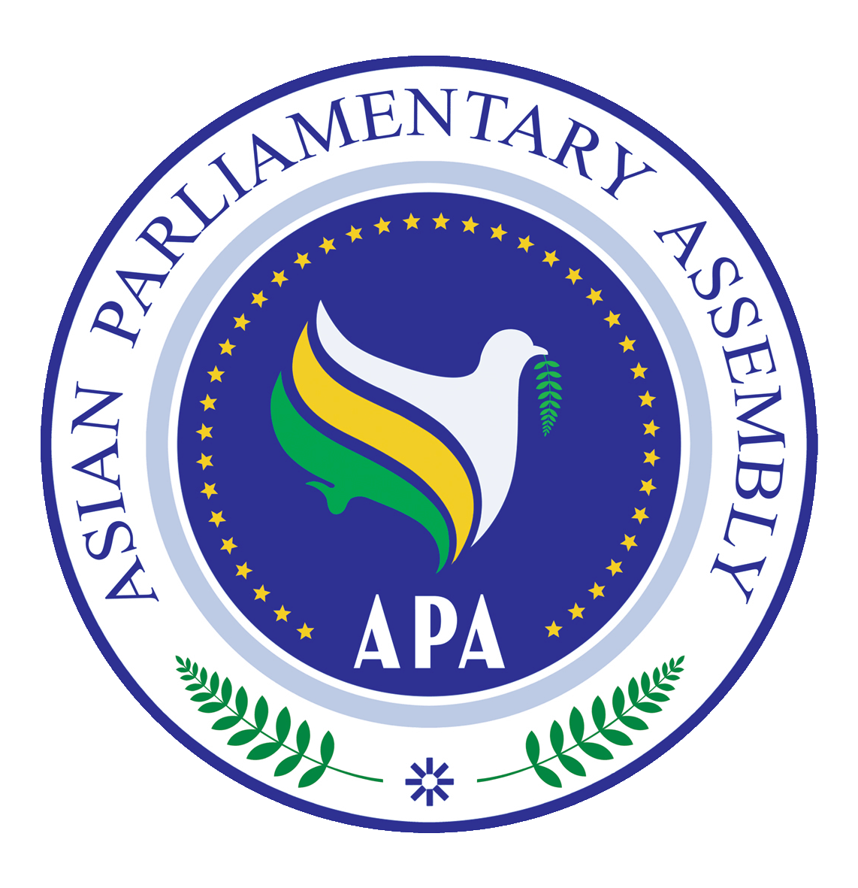 | Asian Parliamentary Assembly |  | EC1/SC-Budget and Planning /Draft Res/2023/01  28 November 2023  Turkiye
Draft Resolution on Planning APA Budget
We, the Members of the Asian Parliamentary Assembly,
Recalling APA/Res/2008/04 and APA/ Res/2014/09 and other relevant APA documents;
Determined to enhance the efficiency and organizational capacity of the APA to achieve its goals and objectives enshrined in its Charter;
Underscoring the importance of participation by all Member Parliaments in sharing the financial needs of the APA and its Secretariat;
Emphasizing the principles of transparency, integrity, accountability, and efficient management of financial resources in APA budgeting and spending;

We therefore,
- Request all APA Member Parliaments to take required measures to secure the necessary funds for the payment of their annual contributions to the APA budget, according to their respective internal budget planning procedures;
- Encourage willing APA Member Parliaments, until their annual contribution is determined, to make voluntary financial contributions over and above their assessed contribution to the APA budget and decisions;
- Appreciate the provision of financial and logistical support to the APA Secretariat by the Islamic Parliament of Iran since 2007, and request the continuation of its generous support pending the full implementation of Financial Regulations and until the regular payments of assessed contributions by all Member Parliaments are made , tentatively for APA budget of 2025;
- Acknowledge the generosity of the APA President and Vice-Presidents in contributing to the APA expenses by hosting activities and meetings based on commitment to the APA Decision on Modalities for Effective Organization of the APA Meetings adopted by the 7th Plenary on 10 December 2013 through supporting APA Secretariat expenses;
- Request the Secretary General to prepare the Draft APA Annual Budget based on the (Program & Performance Budget model), that requires programs, projects and expenses estimation based on the Assembly objectives, and on the policies and plans approved by consensus of the standing committee, and then to be presented to the APA Executive Council for final approval by consensus by the Plenary Session.
- Request the APA Secretary General to provide proposals to be considered in the next meeting of the Standing Committee, based on the views expressed by the APA President during the 13th Plenary on Revitalization for the enhancement of organizational capacity and its effectiveness;
- Allocate the APA Budget through the following three Items:

- Operational and Strategic Budget Item: expenses allocated initially upon the Budget approval and attestation.
- Additional Budget Item: amounts decided to be added to cover APA new projects and programs.
- Emergency Budget Item: which shall be determined by a decision of the APA Executive Council, to cover emergency events or incidents.
- The Secretary General is responsible for the implementation of the APA Budget and the management of its assets;
- The Secretary General shall specify the principles, objectives & rules for the Budget preparation and present it to the Standing Committee on budget and planning;
- Affirm that there should be equal payments for assessed contributions by all member parliaments regardless of population, geographical area or GDP. The amount of such contributions will be discussed and decided during the next meeting of APA Executive Council.
- Recommend to exempt Palestine from the assessed contribution until the end of occupation, and the establishment of its independent state.

